Joe’s Drive

Version 2

Table of Contents

Main Drive Assembly 3

Parts needed for the assembly 3

Chain Pully assembly 3

S2S Gear attachment 4

Gyro / Spin Assembly 5

Dome Mast Assembly 5

Printed Parts needed 5

Mechanical Parts Needed 5

Connection Arms 9

Connecting the X box frame to the mast 11

Head Spin Assembly 13

S2S Assembly 15

Swing Arm Front 15

Electronics 17

Sound Board 17

m0 Feather 17

32u4 Feather 17

Testing S2S 19

PID Determining Balance on your Droid 19

About PID 19

Kp Term 19

Ki Term 21

Kd term 21

# Main Drive Assembly

## Parts needed for the assembly

|  |  |  |  |  |  |
| --- | --- | --- | --- | --- | --- |
| Part Name | QT | P | Price | Total | Link to Purchase |
| 1” x 8” stainless tube cut to 6.75” | 2 | 2 | $8.69 | $17.38 | <https://www.servocity.com/1-00-x-8-00-stainless-steel-tubing/> |
| 40t sprocket | 1 | 1 | $6.39 | $6.39 | <https://www.servocity.com/40-tooth-1-50-aluminum-hub-mount-sprockets-0-250-pitch/> |
| 1” HD Hub | 3 | 3 | $14.99 | $44.97 | <https://www.servocity.com/1-bore-face-tapped-heavy-duty-clamping-hub-1-50-pattern/> |

## Chain Pully assembly

Attaching the chain pulley sprocket to the metal tube placement and alignment

NOTE: With the Jumbo Servo head tilt slots in the back this is considered Front.

This goes on the left side of the drive unit

|  |  |
| --- | --- |
|  |  |

Cut each of the 8” tubing using a pipe cutter to 6.75” and set aside

## S2S Gear attachment

Attach the S2S undercarriage gear using 2 x 10-32 x 2” long flat head bolts

The bolt head goes up through the gear out through the tapered holes on the main frame.

Attach with the 10-32 hex nuts.

# Gyro / Spin Assembly

# Dome Mast Assembly

## Printed Parts needed

for this assembly consist of:

|  |  |  |
| --- | --- | --- |
| Part Name | QTY | Picture of Part |
| Dome mast magnet holder | 1 |  |
| Dome Mast motor mount | 1 |  |
| Dome Mast Spacer | 1 |  |
| Dome Mast | 1 |  |
| Dome X Box | 1 |  |

## Mechanical Parts Needed

to Complete assembly:

|  |  |  |  |  |  |
| --- | --- | --- | --- | --- | --- |
| Part Name | QTY | P | Price | Total | Link to Purchase |
| NeveRest Classic 60 Gearmotor | 1 | 1 | $31.50 | $31.50 | [https://www.andymark.com](https://www.andymark.com/products/neverest-classic-60-gearmotor?Power%20Connector=Anderson%20Powerpole%2015A%20(am-3103)&quantity=1) |
| 0.375" to 6mm Set Screw Shaft Coupler | 1 | 1 | $4.99 | $4.99 | [https://www.servocity.com/](https://www.servocity.com/0-375-to-6mm-set-screw-shaft-coupler/) |
| 3/8" alu, tube | 1 | 1 | $4.09 | $4.09 | [https://www.servocity.com/](https://www.servocity.com/0-375-3-8-x-12-00-aluminum-tubing/) |
| 3/8" bore clamp | 1 | 1 | $6.99 | $6.99 | [https://www.servocity.com](https://www.servocity.com/0-375-0-770-clamping-hub/) |
| 3/8" ID x 5/8" OD Non-Flanged Ball Bearing(2pk) | 4 | 2 | $2.79 | $5.58 | [https://www.servocity.com](https://www.servocity.com/3-8-id-x-5-8-od-non-flanged-ball-bearing-2-pack/) |
| 1” ID bearing | 4 | 4 | $9.99 | $39.95 | [https://www.servocity.com](https://www.servocity.com/1-id-x-1-245-od-flanged-ball-bearing/) |
| #10 threaded rod (will cut into 2 x 125mm length) | 1 | 1 | $1.14 | $1.14 | [https://www.mcmaster.com/](https://www.mcmaster.com/90032A048) |
| #10 rod ends (RH Thread) | 4 | 4 | $3.59 | $14.36 | <https://www.mcmaster.com/60645K31> |

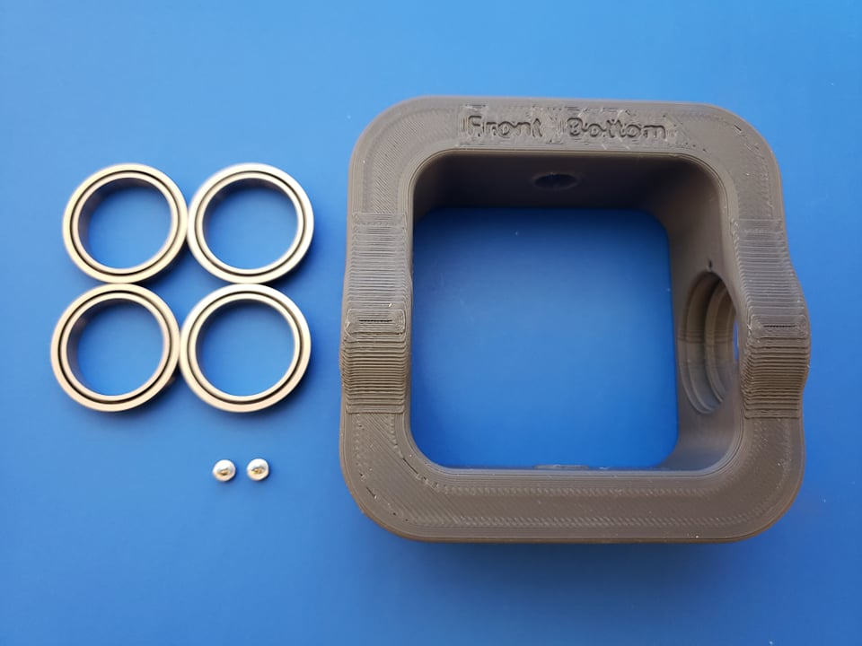

You will need 4 1” bearings and 2 smaller placement tacks to hold the #10 rod ends that are cut to connect the Y mast piece.

Insert 4 of the larger bearings into the X box frame (2 on the inside and 2 on the outside)

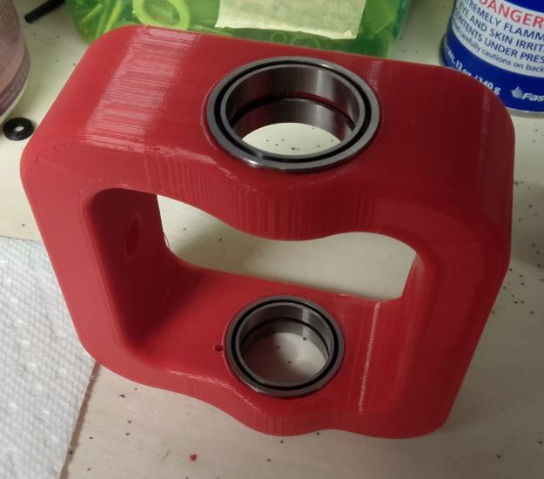

Insert the 4 smaller bearings into the Dome Mast, 2 into the lower portion to where the Mast will attach to the Y axis frame.

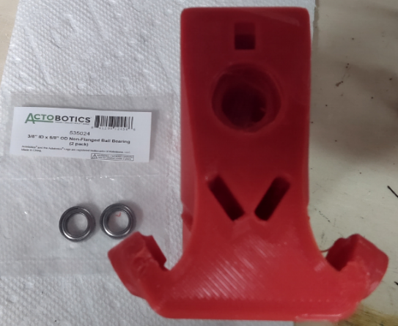

2 more in the upper portion where the alum tube passes through between the motor and the upper magnet holder.

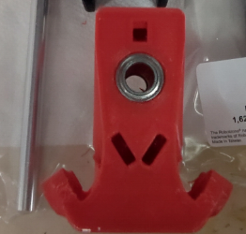

## Connection Arms

Take the #10 threaded rod and cut 2 sections at 125mm length using a hack saw or rotatory disc… I used my ole saw zaw… and used pliers to trim the flacking on the end. While its hot, screw that into the rod ends to ensure the screw lines work.

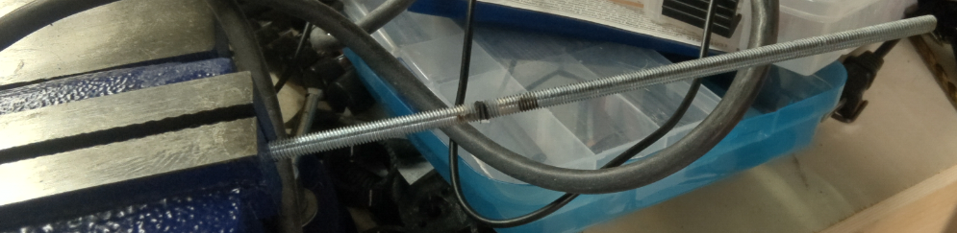

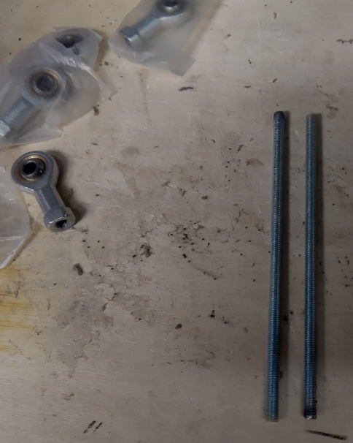

You will end up with similar pieces roughly 125mm, the important part is when assembling them to the Right-Handed Rod Ends, they are the same length.

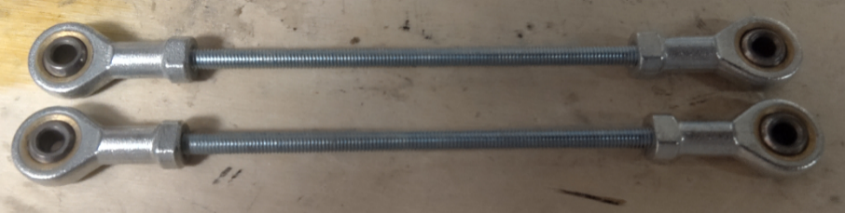

You will need 2 x 10x32 1 1.4” length flat head bolts and 2 x square nuts as these will be used to bolt the one end of the push arms into the mast.

Insert the square nuts into the top flat inserts. push them all the way down. You can use a smaller screwdriver or the like to push through the holes and verify the nut is in alignment.

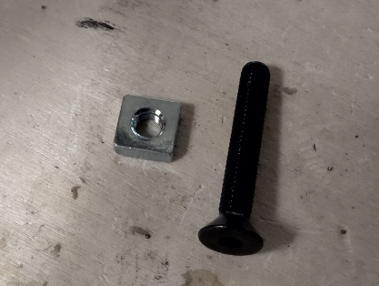 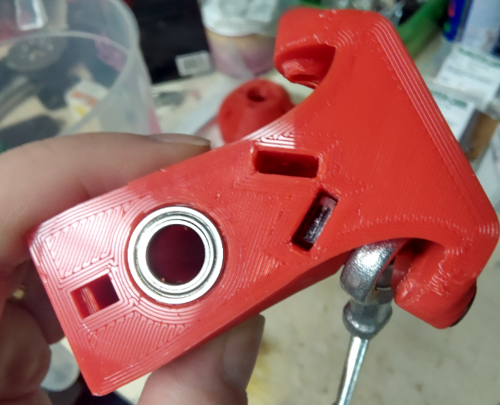

Push the bolt through the outer portion and through the rod ends and into the main body where the square nut is… tighten into the nut. Perform the same step for the other side… you should end up with something similar as below.

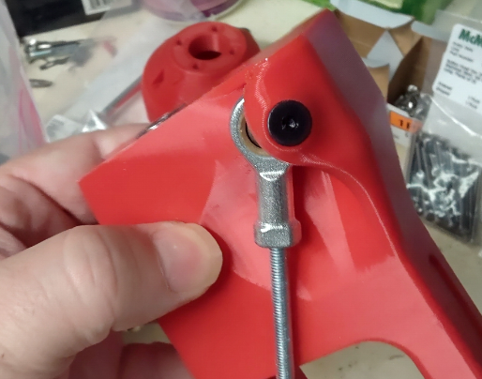 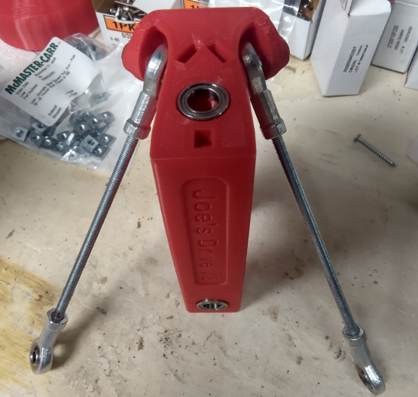

## Connecting the X box frame to the mast

With the X box frame, insert 4 x 1” ID bearings in all the holes

You will end up with the X box frame looking like below



We will need to cut the 1” x 12” tubing into 2 x 26mm length pieces.

I used a Dremel with a metal blade to cut through clean.

I marked the length and placed in vice and used the Dremel to cut through

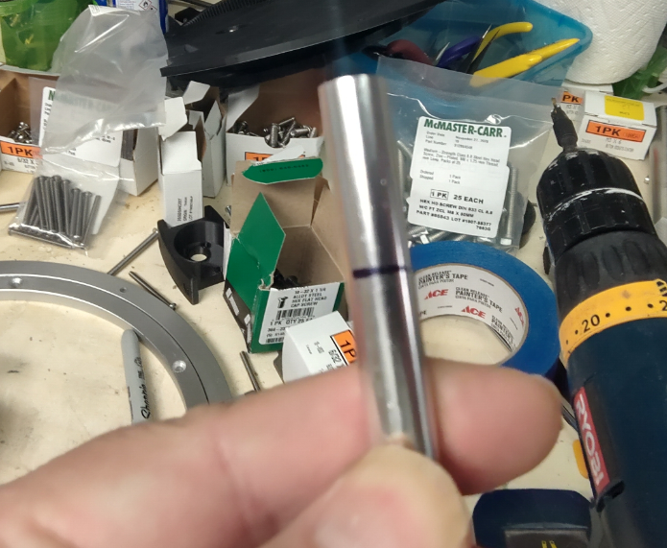 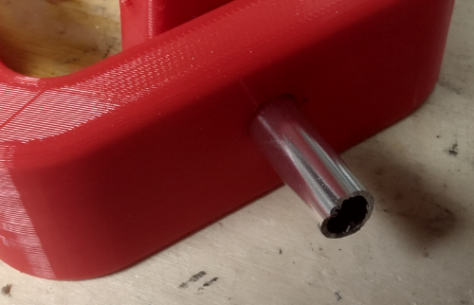

Inserted each piece aligning the box to the mast.

IMPORTANT: the round ends face down and the larger 1” ID bearing path must align to the Bearings for the head rotation. See below image for reference.

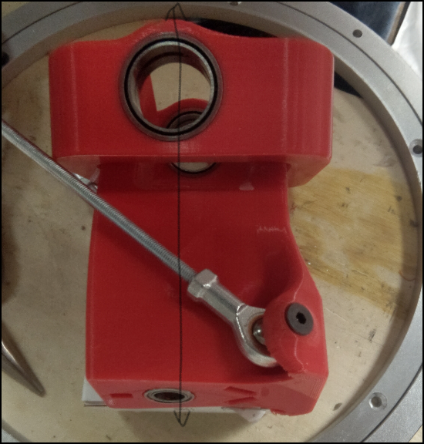

## Head Spin Assembly

You will need 4 x 3mm x .50 length screws to lock the AndyMark Gearmotor to the dome mast motor mount

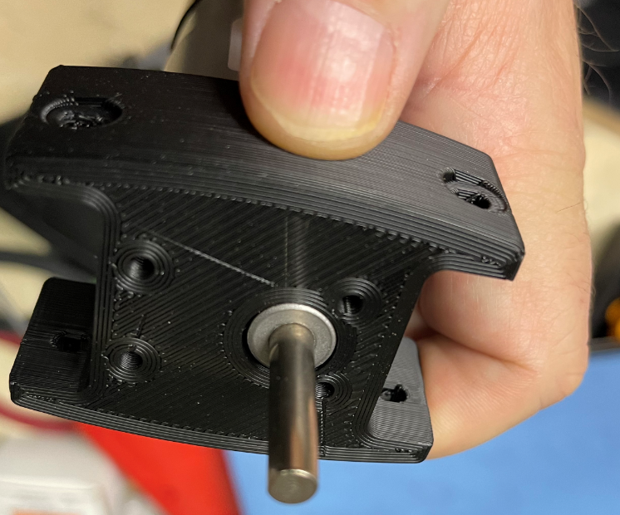 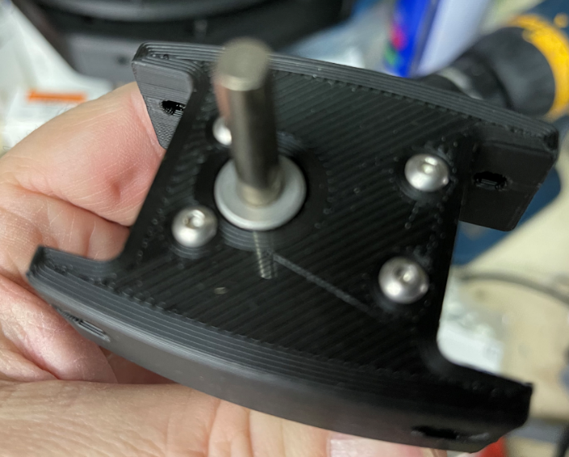

Apply power to the servo to spin the shaft so the flat is facing to the side of the unit.

This will make it easier for adjustment and tightening the Coupler once its inserted into the mast frame.

Apply the grubs to the coupler and place the smaller end of the coupler over the shaft of the servo sliding it down so the servo shaft protrudes out of it... The 8mm hollow shaft we cut up earlier will be used to insert into the other end of the coupler and will fit over the shaft...

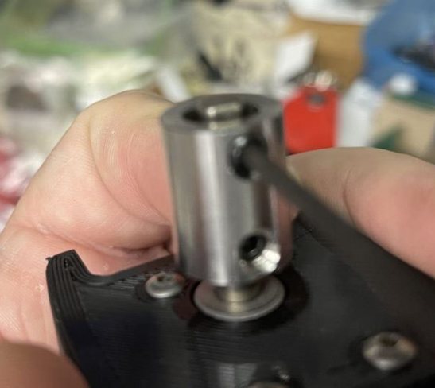 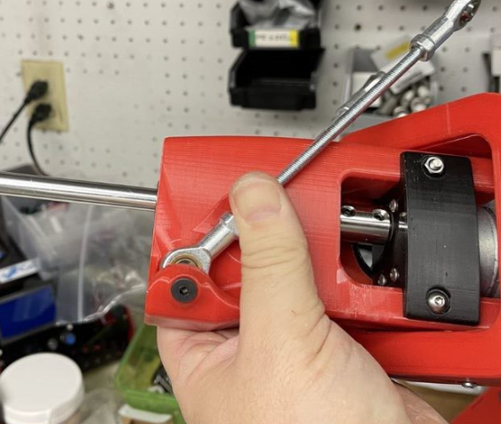

Tighten down the smaller/thinner portion are onto the flat of the shaft on the servo

Lock the dome mast servo mount into the mast using 2x m4x45mm length bolts and nuts.

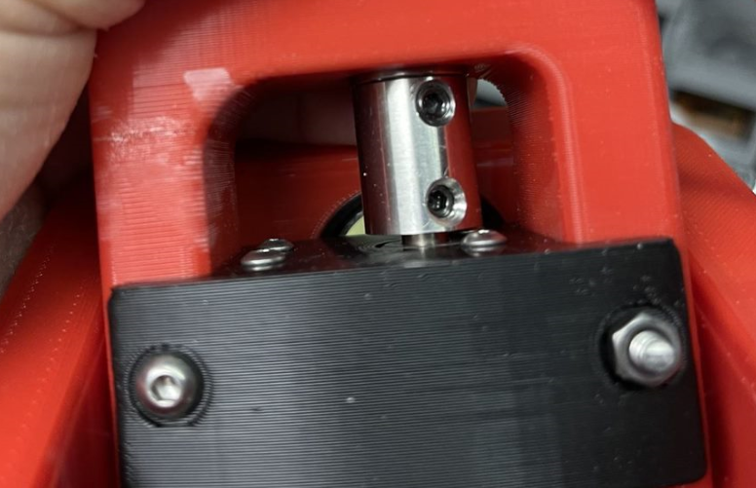

# S2S Assembly

## Swing Arm Front

Assembling the front swing arm assembly will require

|  |  |  |  |  |  |
| --- | --- | --- | --- | --- | --- |
| Part Name | QT | P | Price | Total | Link to Purchase |
| Worm gear motor (65rpm) | 1 | 1 | 29.29 | 29.29 | [https://www.amazon.com/](https://www.amazon.com/gp/product/B07KLMM49K/ref=ppx_yo_dt_b_search_asin_title?ie=UTF8&psc=1) |
| 40t sprocket | 1 | 1 | $6.39 | $6.39 | <https://www.servocity.com/40-tooth-1-50-aluminum-hub-mount-sprockets-0-250-pitch/> |
| 1” HD Hub | 3 | 3 | $14.99 | $44.97 | <https://www.servocity.com/1-bore-face-tapped-heavy-duty-clamping-hub-1-50-pattern/> |

2 x Bearings

2 x 6x32 1/2

2 x 6x32 3/8

2 x 10x32 x 1 ¼"

Make sure you use the appropriate screws on the worm drive where the screws closer to the stem are the 1/2 in length and the screws further away are the 3/8 in length

You can mount the Swing Arm front to the lazy Susan bearing once you taper the holes to reduce the exposure of the bolt.

Insert the 2 10x32 bolts through the bottom of the bearing up into the swing arm assembly

Lock down the bolts using 2 m5 x .8mm flange locknuts

Insert 2 x Bearings through the bearing holes on the upper part of the arm

Make sure they are flush as much as possible

We will insert into the main frame 1 x M8 x 55mm bolts inward out (inserting the hex head into the groove already printed out of the frame.

Connect the 8mm set screw hub slightly against the side of the Swing Arm... leaving a little wiggle room (so its not scraping when rotating and digging into the arm).

Tighten down the bore against the side that is flat... this will prevent it from slipping.

Connect the S2S motor gear placing it over the screw hub (note there is a insert enough to allow the end of the worm drive shaft to protrude out of the hub slightly.

Tighten down with 4 x 6/32 1/2 “ screws tightly... note the gear should still be slightly spaced away from the front mount enough to rotate without digging into it.

Completed assembly example

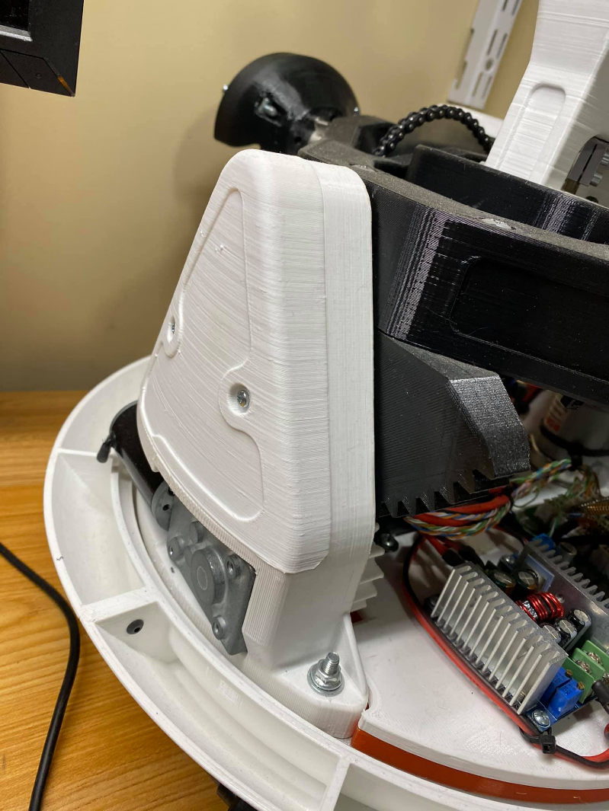

# Electronics

## Sound Board

I2c Communications

## HUZZAH Feather

reads mpu,

reads pot

Controls all body motors

32u4 FEATHER

SND BOARD

M0 FEATHER

## 32u4 Feather

Controls Dome motors/servos

voltage sensor

hall sensor

encoder.

Driv1

Connects to the motor controller that services: S2S, MainDrive

Driv2

Connects to the motor controller that services: DomeSpin and Gyro

# Calibration of the MPU/IMU

What I do to get calibration values using trinket is the following:

1. Put the MPU6050 in a flat and horizontal surface. Use an inclinometer to check that it is as horizontal as possible.
2. Modify the RAW program (**TrinketMPUCalibration**) to put every offset to 0. ("setXGyroOffset/setYGyroOffset/setZGyroOffset/setZAccelOffset"  =0 ).
3. Upload the program (TrinketMPUCalibration) to your trinket and open serial monitor so you can see the values it is returning.
4. Leave it operating for a few **minutes (5-10**) so temperature gets stabilized.
5. Check the values in the serial monitor and write them down.
6. Now modify the trinket program **TrinketMPUCalibration** again updating your offsets and run the sketch, with updated offsets.
7. Repeat this process until your program is returning 0 for every gyro, 0 for X and Y accel, and +16384 for Z accel.

Once you achieve this, those are the offsets for that MPU6050, you will have to repeat this for every MPU6050 you use.

Add these values to the main

*NOTES:

- If you stop the sketch for a while, sensor's temperature will get lower. If you only stop it to reprogram new offsets, you dont need to wait those 5-10 minutes every time.

# Testing ENC (DomeSpin Position)

The dome positioning is complete with the use of a encoder built into the motor (NeveRest Classic 60 Gearmotor) made by AndyMark <https://www.andymark.com/products/neverest-classic-60-gearmotor?via=Z2lkOi8vYW5keW1hcmsvV29ya2FyZWE6OkNhdGFsb2c6OkNhdGVnb3J5LzViYjYxOGI0YmM2ZjZkNmRlMWU2OWZkZg> . Those encoders allow direction positioning based on PinA and B feeding back positioning.

On the secondary code

Uncomment **#define debugENC**

This allows direct positioning with joystick (bypassing enable drives protocol) and allow checking the ENC values and the Dome Center positioning is.

# Testing S2S

The Side to Side is a combination of Potentiometer (so we know where it is) versus the IMU PITCH which shows actual to real world tilt causing the actual inner frame to rotate over 45degrees left to right.

Uncomment #define debugPOTS

Then check the Setpoint2, S2S_pot and Input2

Keep the **S2S_pot** value between -17 and 17 for proper PID control of left/right motion

# PID Determining Balance on your Droid

Each BB8 will be different, regardless of using the exact parts, this is due to the fact that all the sensors and measurements will have differing values based on manufacturer and weight of the parts (based on your printing) etc…

On the secondary code

Uncomment **#define debugPID**

this will allow testing balancing of the S2S frame without having to use the joysticks.

## About PID

Lets discuss the PID values and where we adjust based on findings…

The sensor (the MPU-6050 in our case) sends the new current position of the robot’s S2S frame back to the 32u4 Feather, which calculates the error and does the whole process again. This is called feedback and makes this type of control loop a closed-loop system (as opposed to an open-loop system, which is easier but much less accurate).

## Kp Term

The proportional term (gain) makes a change to the output that is proportional to the current error value. Larger values typically mean faster response since the larger the error, the larger the Proportional term correction signal. However, an excessively large proportional gain will lead to instability and oscillation. In layman’s terms, the further away from the desired state the robot is in, the larger the proportional term will need to be to correct it.

So if your S2S frame is wobbling a lot or is very off balance, you might need a larger Kp term to offset that because the robot is going to be further off balance. Here is a picture on what certain Kp values might look like:

[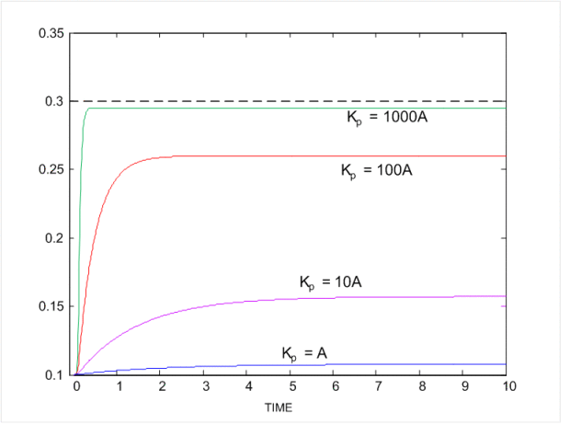](https://osoyoo.com/wp-content/uploads/2018/08/kp2.png)

So A is e(t), and the value before A is the Kp value. You can see that larger values of Kp help the system achieve stability faster. However, you can overdo it. Too much Kp will give severe oscillations, as seen here:

[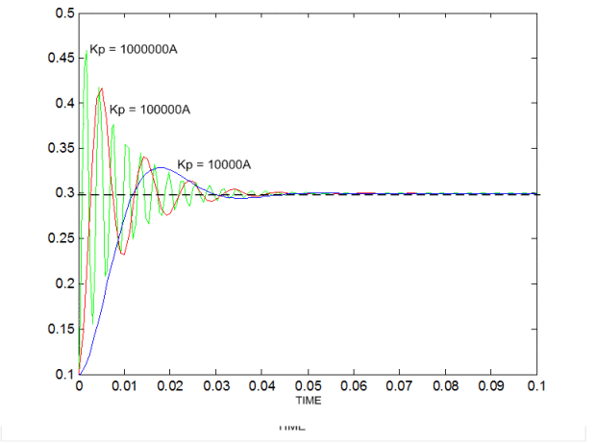](https://osoyoo.com/wp-content/uploads/2018/08/kp1.png)

Note that these Kp values are NOT recommended values for your robot, they are general values only to illustrate a point. My actual Kp value for the balancing robot was 40. Less than that gave a sluggish robot that oscillated wildly, while more than that was too aggressive an approach (like the 100000A example above). The original Franko robot had a value of 70. It all depends on the robot, even two robots that have the same purpose.

## Ki Term

For the balancing S2S frame, a large Ki will enable it to steady itself very quickly, and will help eliminate drift. If you look up videos of balancing robots on YouTube you will see that a lot of them will roll around. That is because of their steady state error, and a larger Ki will stop that (as long as it’s not too large). Mine was set at 500, which is over 7 times greater than the Kp value.

## Kd term

To translate, the Kd term helps the Kp term not overshoot the mark and reduces oscillations. Too large of a Kd term will slow down the response of the robot and make it slower to balance, while too small of a Kd term will make it shake a lot. Mine was set at 1.9, so much smaller than either the Kp or Ki terms.